2023 Brimwood Farm Transect Survey
26th January 2023

Our new monthly survey acts as an additional monitoring method alongside the more general biodiversity list. Whereas the latter provides an overall snapshot of all wildlife seen on site, the transect survey (route shown in the image below) provides a regular report which captures a snapshot of data from one given day per month. This should help to highlight pattens in wildlife movement and establish baseline numbers of resident animals.
Winter surveys are, unsurprisingly, simple walk-through’s. However, during the more active months of the year, more detailed surveys will be conducted to count numbers of specific groups – birds, butterflies, insects, etc.
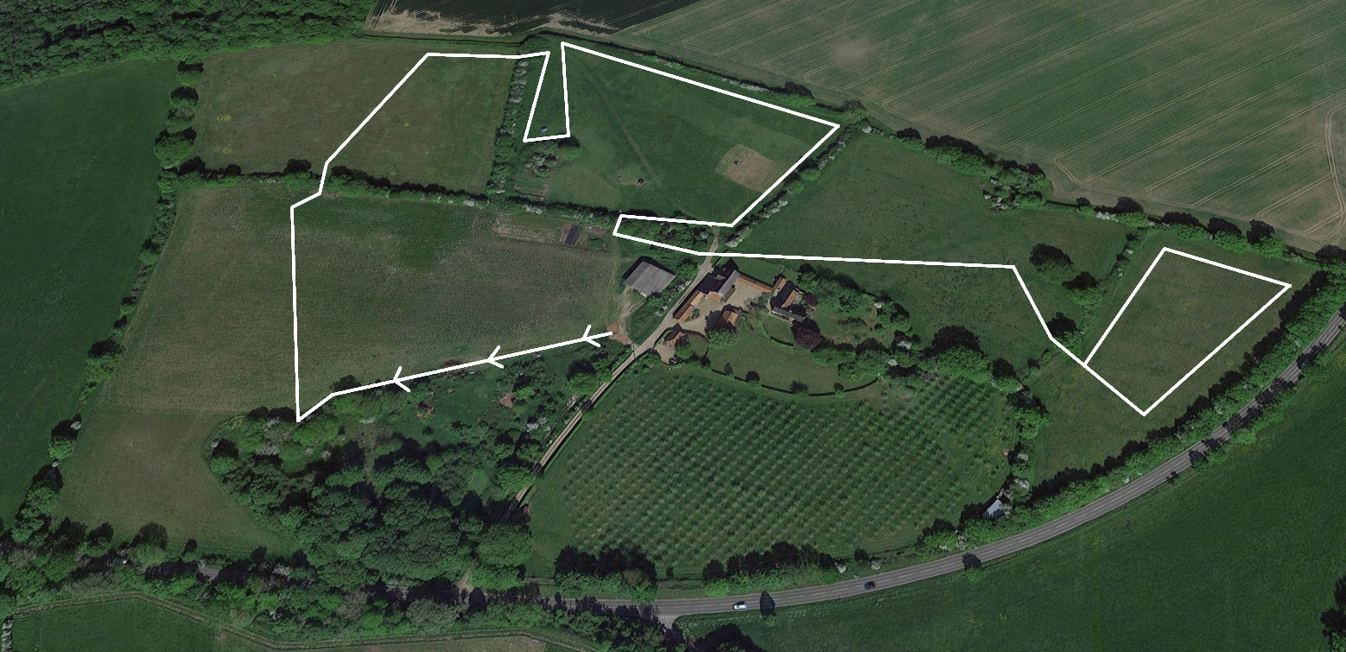

Findings from January 26th 2023
Weather; damp, overcast, drizzly.

Birds:
Dunnock x 1
Blue Tit x 3
Crow x 1
Blackbird x 6
Wren x 2
Robin x 1
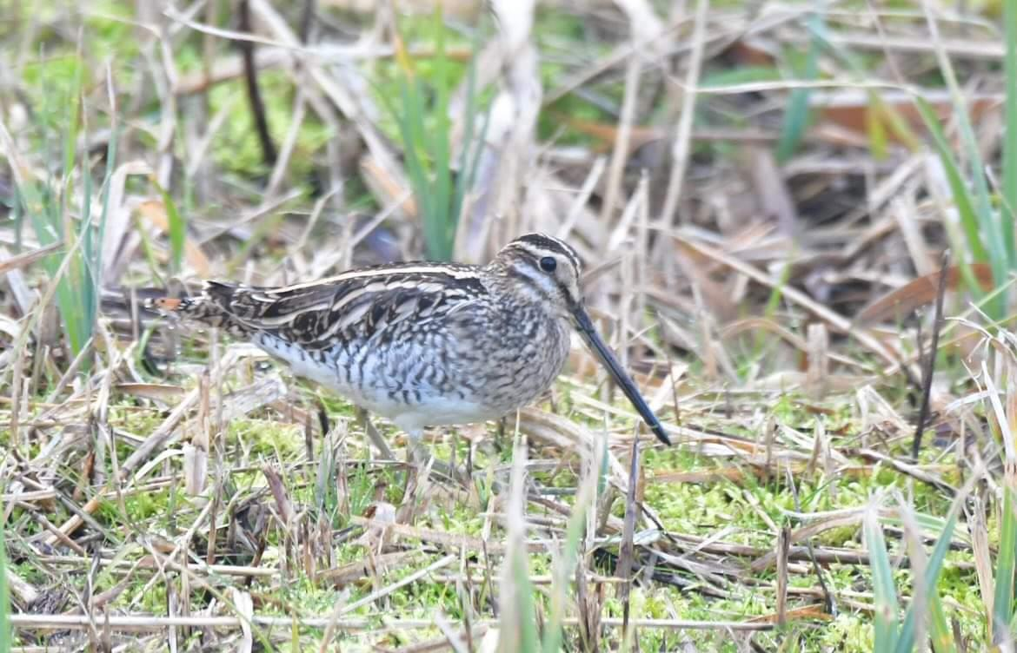
Meadow Pipit x 5
Rook x 50
Jackdaw x 4
Goldfinch x 8
Snipe x 1
Pied Wagtail x 8
Greenfinch x 2
Great Tit x 1
Fieldfare x 10
Wood Pigeon x 1
Redwings x 7
Ring-necked Pheasant x 1

Mammals:
Field Mouse x 1

Of Particular Note
Excitingly, the survey identified seven species that were not currently included on the biodiversity list. Though some of these had been spotted before, they’d not been included as not properly ID’d. This includes the spotting of a snipe in the wildflower meadow (picture included) and the pied wagtails that frequent the turf piles rooted up by the pigs.
Others to be spotted for the first time were redwings and fieldfares which are migratory and more likely seen on farmland during winter. Meadow pipits and crows were also recorded.

